10.1

a.

In part (a) just write the logit equation from your model (part i).

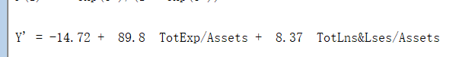

b.



Logit is 0.18, odds is 1.197, probability is 0.545 and the classification is 1.

c.

odds = p/(1-p) = 1. So, the threshold based on odds is 1.

Logit = ln(1) = 0. So, the threshold based on logit is 0.

d.

odds[(TotLns/Assets) + 0.1] / odds(TotLns/Assets) = e^0.837 = 2.31.

The odds being financial weak increases 2.31 times.

d\*(x)

0.717744/ 0.544879 = 1.317255.

e.

We could only accept we misclassified a strong bank. So we need to increase the cutoff.